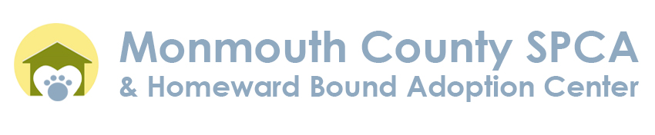
TITLE: Full-Time Client Service Representative
Professional Client Service Skills:
- Display exceptional interpersonal communication skills
- Possess a strong desire to help people with their interests, needs and inquiries involving animal welfare and ownership
- Commitment to the shelter mission to prevent animal cruelty
- Work well in a team environment while being able to self-initiate within organization guides
Fundamental Job Responsibilities:
- Maintain shelter animal records
- Responsible for the admission and disposition of animals
- Maintain accurate, detailed records of all animals in the shelter – place notes in animal files and the digital database to keep information up-to-date
- Screen and schedule incoming animal admission appointments
- Record lost and found reports of local pets
- Follow up on special cases: quarantine, domestic violence, fire/storm victims
Working knowledge of:
- Computers (Windows, M/S Office products)
- Fax/Copy/Scanning equipment
- Charge card readers
- Adaptability to learn Cornerstone Software by Idexx and other shelter-based software
Duties Include:
- Report/record daily statistical information
- Balance daily financial reports
- Greet, assist, and direct public
- Answer telephone calls promptly, courteously and give accurate information
- Educate general public on good pet ownership and wildlife in the community
- Sell/promote merchandise and fundraising items or events
Basic Requirements:
- High School diploma or equal certificate
- Ability to speak and understand English. Qualified candidates possessing conversational bilingual skills will receive additional consideration
Schedule: 10:00 AM to 5:00/7:00, involves weekends.
Salary TBD

