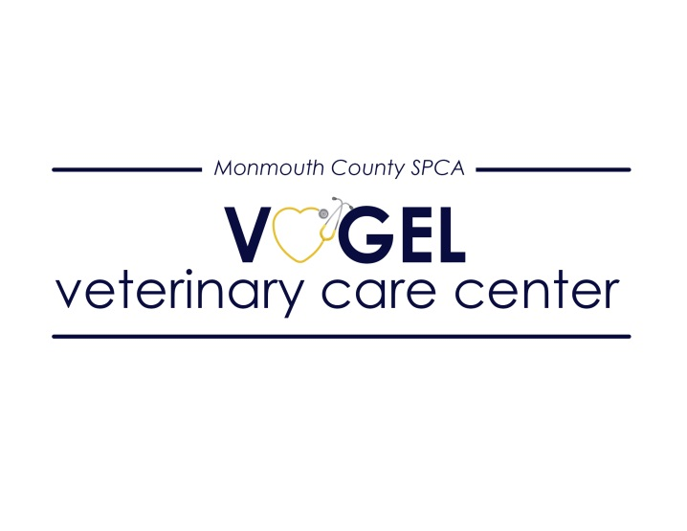
Great mission. Great environment. Great people. Join our team...
The MCSPCA Vogel Veterinary Care Center is seeking experienced veterinary assistants to join our team! Our three doctor practice is rapidly growing and seeking positive, versatile, qualified individuals to support our future endeavors.
At the MCSPCA Vogel Veterinary Care Center, our mission is to elevate the level of veterinary care in our community by providing quality services accessible to all animals and their families. We provide care to a variety of patients, including those seeking sick and well care, spay/neuter procedures, anesthetic dentals, and other surgeries. The VVCC is a dynamic fast-paced environment, where positivity and efficiency are key to providing both outpatient medical services and safe surgical procedures to thousands of animals each year.
We are a forward-thinking clinic with modern equipment, including new anesthesia machines, advanced patient monitoring devices, a full in house Idexx laboratory suite, ultrasound, digital radiography, dental machine, and dental radiography. The candidate will work with a team of highly skilled veterinary technicians and assistants in providing the highest-quality care possible.
The VVCC offers very competitive compensation, comprehensive benefits for full-time employees including 90% employer funded health insurance premiums, generous paid time off, and access to a retirement plan option. Additionally, our employees are eligible for the Public Service Loan Forgiveness Program after 10 years of employment.
Requirements:
- One year in the veterinary field
*This job description is subject to change based on the needs of the organization and discretion of the medical director.
Please contact Gina Lawson, Clinic Manager for more information or to apply. gina@vogelvet.org

