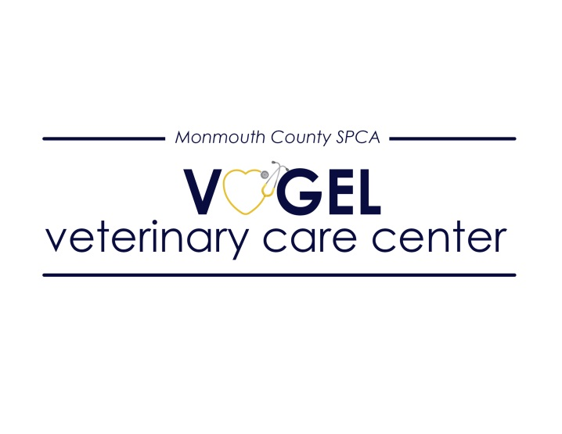
The MCSPCA Vogel Veterinary Care Center is seeking a motivated and skilled technician to join our accomplished team in performing thousands of spay/neuter surgeries each year.
Our high quality high volume Spay Neuter Clinic is a dynamic fast-paced environment, where efficiency is key to providing safe surgical procedures and quality peri-operative care to dozens of animals each day. We are a well-established facility in beautiful Monmouth County, NJ, that serves a diverse client base, including MCSPCA shelter animals. By making spay and neuter more accessible for all pet owners, we hope to reduce pet overpopulation, animal cruelty and neglect.
We are a forward-thinking clinic with modern equipment, including new anesthesia machines, advanced patient monitoring devices, and suction and cautery equipment. The candidate will work with a team of highly skilled veterinary technicians and assistants in providing the highest-quality care possible.
The Vogel Spay Neuter Clinic offers very competitive compensation, comprehensive benefits for full-time employees including 90% employer funded health insurance premiums, generous paid time off, and access to a retirement plan option. Additionally, our employees are eligible for the Public Service Loan Forgiveness Program after 10 years of employment.
Requirements:
- Two years in the veterinary field with at least one year of surgical/anesthesia experience
- Certification/licensure is preferred.
*This job description is subject to change based on the needs of the organization and discretion of the medical director.
Please contact Gina Lawson, Clinic Manager for more information or to apply. gina@vogelvet.org

